Assignment 2&3
- Installed python with sudo dnf install python3 -y and python3 –version
- For crontab practice I created new script file, wrote some basic text to test the scheduling and added entry so it would run every minute, then tested if its working.
mkdir -p ~/scripts
cd ~/scripts
nano collect_data.sh
#!/bin/bash
echo "Cron job ran at $(date)" >> ~/cron_test.log
chmod +x ~/scripts/collect_data.sh
./collect_data.sh
cat ~/cron_test.log
crontab -e
* * * * * /home/mariia/scripts/collect_data.sh
systemctl status crond
tail -f /var/log/cron
cat ~/cron_test.log

- Installed apache

sudo yum install httpd -y
sudo systemctl enable httpd –now
systemctl status httpd
sudo firewall-cmd --permanent --add-service=http
sudo firewall-cmd --permanent --add-service=https
sudo firewall-cmd –reload
sudo setsebool -P httpd_enable_homedirs 1
sudo setsebool -P httpd_read_user_content 1
curl -I http://localhost/

Then I ran into some problems with accessing the page(Everything was fine with configurations, it was just my mistake – I tried to access locahost on my laptop itself, which obviously did not work, but I did not understand the problem at first at spent a lot of time troubleshooting and checking if firewall is fine, ports are listening etc and could not see the problem. Then I realised how obvious was the actual problem and that I need to connect through port forwarding.

- Created separate users web directories

nano /etc/httpd/conf.d/userdir.conf
mkdir -p ~/public_html
echo "<h1>Hello from ~userdir</h1>" > ~/public_html/index.html
chmod 711 ~
chmod 755 ~/public_html
chmod 644 ~/public_html/index.html
curl -I http://localhost/~mariiaat/
curl http://localhost/~mariiaat/
tail -n 200 /var/log/httpd/error_log
tail -n 200 /var/log/httpd/access_log

- Created passwords

su - mariiaat
htpasswd -c ~/.htpasswd kake
htpasswd ~/.htpasswd anotheruser
mkdir ~/public_html/somesecret
nano ~/public_html/somesecret/.htaccess
chmod 711 ~
chmod 755 ~/public_html ~/public_html/somesecret
chmod 644 ~/public_html/somesecret/.htaccess
restorecon -R -v ~/public_html
sudo systemctl restart httpd
then tested protection
curl -I http://localhost/~username/somesecret/
got an auth prompt, entered credentials and all worked!
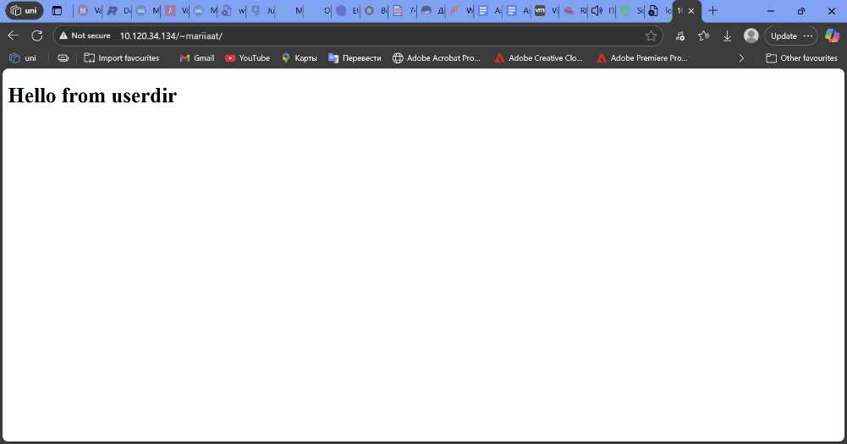

Changing documents to new root(assignment3)
sudo -i
mkdir -p /var/newroot
echo '<h1>Hello from newroot<h1>' > /var/newroot/index.html
ls -l /var/newroot
chmod 755 /var/newroot
chmod 644 /var/newroot/index.html

edited apache configurations:
nano /etc/httpd/conf/httpd.conf

replaced old DocumentRoot with:
DocumentRoot "/var/newroot"
<Directory "/var/newroot">
Options Indexes FollowSymLinks
AllowOverride None
Require all granted
</Directory>
systemctl restart httpd
systemctl status httpd --no-pager
curl -I http://localhost/
curl http://localhost/

restarted apache and tested it. As was expected, it didn’t work, so continued with SELinux:
semanage fcontext -a -t httpd_sys_content_t "/var/newroot(/.*)?"
restorecon -R -v /var/newroot
systemctl restart httpd
curl -I http://localhost/
curl http://localhost/

allowed home directories

setsebool -P httpd_enable_homedirs on
nano /etc/httpd/conf.d/userdir.conf

